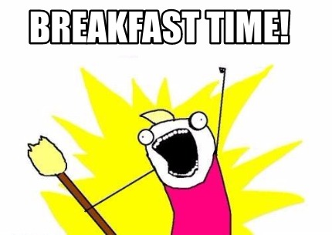
APRIL 29, 2023
TICKETS $15.00
8:00AM-DOORS OPEN
SCRAMBLED EGGS, PANCAKES, HAM SAUSAGE, POTATO, COFFEE, OJ, FRUIT
902 MILL RD. LEHIGHTON PA 18235 (MAHONING VY. AMBULANCE ASSN.)
GUEST SPEAKER
PATTY B. YORK, PA
CONTACT FOR INFORMATION & TICKETS:
CHRIS H 570-294-2118
MIKE R. 570-527-8661 / RYAN M. 570-401-3903
MONICA A./ KAREN H. / MARY ANN K.
50/50 and BASKET RAFFLES

